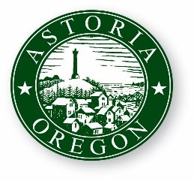
AGENDA

ASTORIA CITY COUNCIL WORK SESSION
Wednesday, April 12, 2017
9:00 AM
2nd Floor Council Chambers
1095 Duane Street Astoria OR 97103

- CALL TO ORDER

- ROLL CALL

- PRESENTATION

  - Parks Department Budget Discussion

- ADJOURNMENT

